Single joint movements

1. Shoulder XZ movement

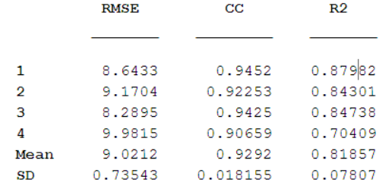

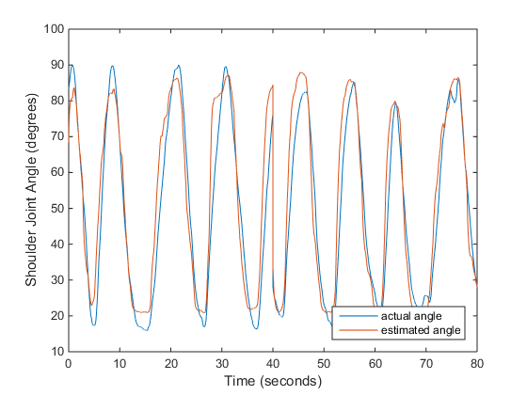

Figure 1 - Fold 1 - with CV

1. Shoulder XY movement

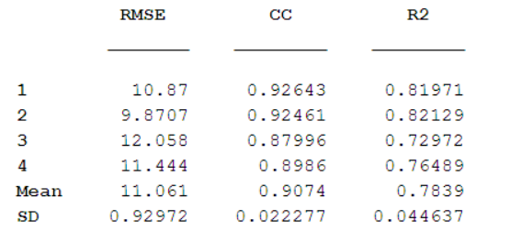

1. Shoulder YZ movement

